|  |  |  |
| --- | --- | --- |
| |  |  | | --- | --- | | |  | | --- | | *Human Perspectives ATAR Units 3 & 4* | | |

Worksheet 12.1 Adaptations for erect posture

Answers

Use this worksheet to summarise the adaptations for erect posture. Annotate the diagram by describing what the adaptations are and explaining how they contribute to erect posture and bipedal locomotion.

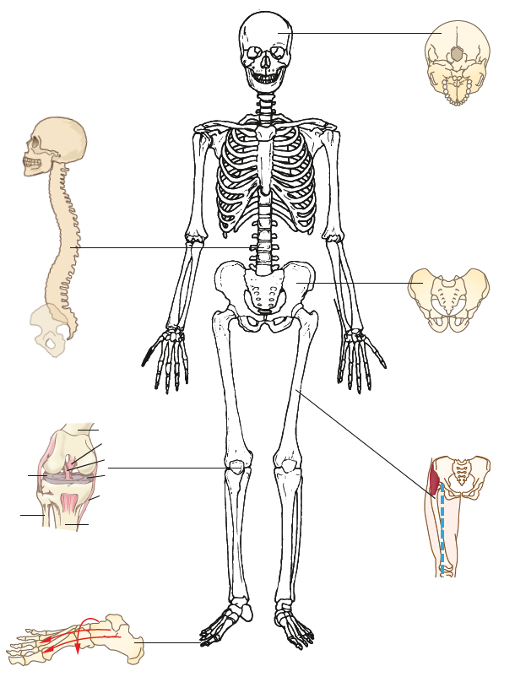

Foot: Two arches transverse and longitudinal, turns the foot into a complex spring, distributes the weight from the heel, to the aligned big toe when striding.

Knee: Two-part hinge; the outer hinge is larger and stronger. Weight distribution falls in front of the knee, ligaments allow for a natural resistance, and no energy required to support when standing.

‘S’ shaped spine: Double curvature is achieved with wedge-shaped lumbar vertebrae and a cervical curve to bring the vertebral column directly under the centre of gravity of the skull.

Carrying angle: Formed by the convergence of the femur toward the knee and results in weight distribution that is close to the central axis of the body when walking. Greater stability when standing upright, enables a striding gait.

Pelvis: Broader and shorter from top to bottom and bowl shaped, supports the abdominal organs when standing upright, and is more stable for bipedal locomotion.

Foramen magnum: Centralised to allow the skull to balance on top of the vertebral column, removing the need for large neck muscles.